USDA ARS expression data READ.ME file: 5/24/2019

The accompanying .csv file contains gene expression data obtained from a laboratory Dermo challenge experiment conducted by the USDA ARS Shellfish Genetics lab in summer 2015. Individuals from three selectively-bred families from the VIMS eastern oyster breeding program were subject to challenge, phenotyped for parasite elimination rate and survival, and sequenced for RNAseq and differential expression analysis.

Resistance was quantified by parasite elimination rate; the family with the greatest elimination rate was the most resistant; however, resistance did not correspond with survival.

The tolerant family eliminated the parasite at a more modest rate and survived exceptionally well.

The susceptible family did not eliminate the parasite and exhibited high mortality in the exposed treatment.

Experimental design for sequencing is as follows:

|  |  |  |  |
| --- | --- | --- | --- |
| Family | Treatment | Time | # Ind Sequenced |
| Tolerant (LB) | exposed | 36hr | 5 |
| Tolerant (LB) | exposed | 7d | 5 |
| Tolerant (LB) | exposed | 28d | 5 |
| Tolerant (LB) | control | 36hr | 5 |
| Tolerant (LB) | control | 7d | 5 |
| Tolerant (LB) | control | 28d | 5 |
| Resistant (DC) | exposed | 36hr | 4 |
| Resistant (DC) | exposed | 7d | 5 |
| Resistant (DC) | exposed | 28d | 5 |
| Resistant (DC) | control | 36hr | 5 |
| Resistant (DC) | control | 7d | 5 |
| Resistant (DC) | control | 28d | 5 |
| Susceptible (DA) | exposed | 36hr | 5 |
| Susceptible (DA) | exposed | 7d | 5 |
| Susceptible (DA) | exposed | 28d | 5 |
| Susceptible (DA) | control | 36hr | 5 |
| Susceptible (DA) | control | 7d | 6 |
| Susceptible (DA) | control | 28d | 6 |

Comparisons for differential expression analysis were made between the two treatments, within each family, at each time point. For example, tol36h columns in the accompanying .csv file correspond to the comparison between exposed and control groups within the tolerant family at 36 hours post exposure.

Thus, the .csv is organized into columns as follows: Gene ID (XP), log2FoldChange, pvalue, FDR, and DE status (sig) for each of the comparisons we made: tol36h, tol7d, tol28d, res36h, res7d, res28d, sus36h, sus7d, sus28d. This resulted in a total of 40 columns.

Cutoffs of log2fFoldChange ≥ 1 AND FDR ≤ 0.05 were used to identify DEGs.

A figure showing patterns of differential expression over time for each of the three families is included below as a point of reference. A version of this figure will be included in a USDA stand-alone publication, so please keep it between us for now.

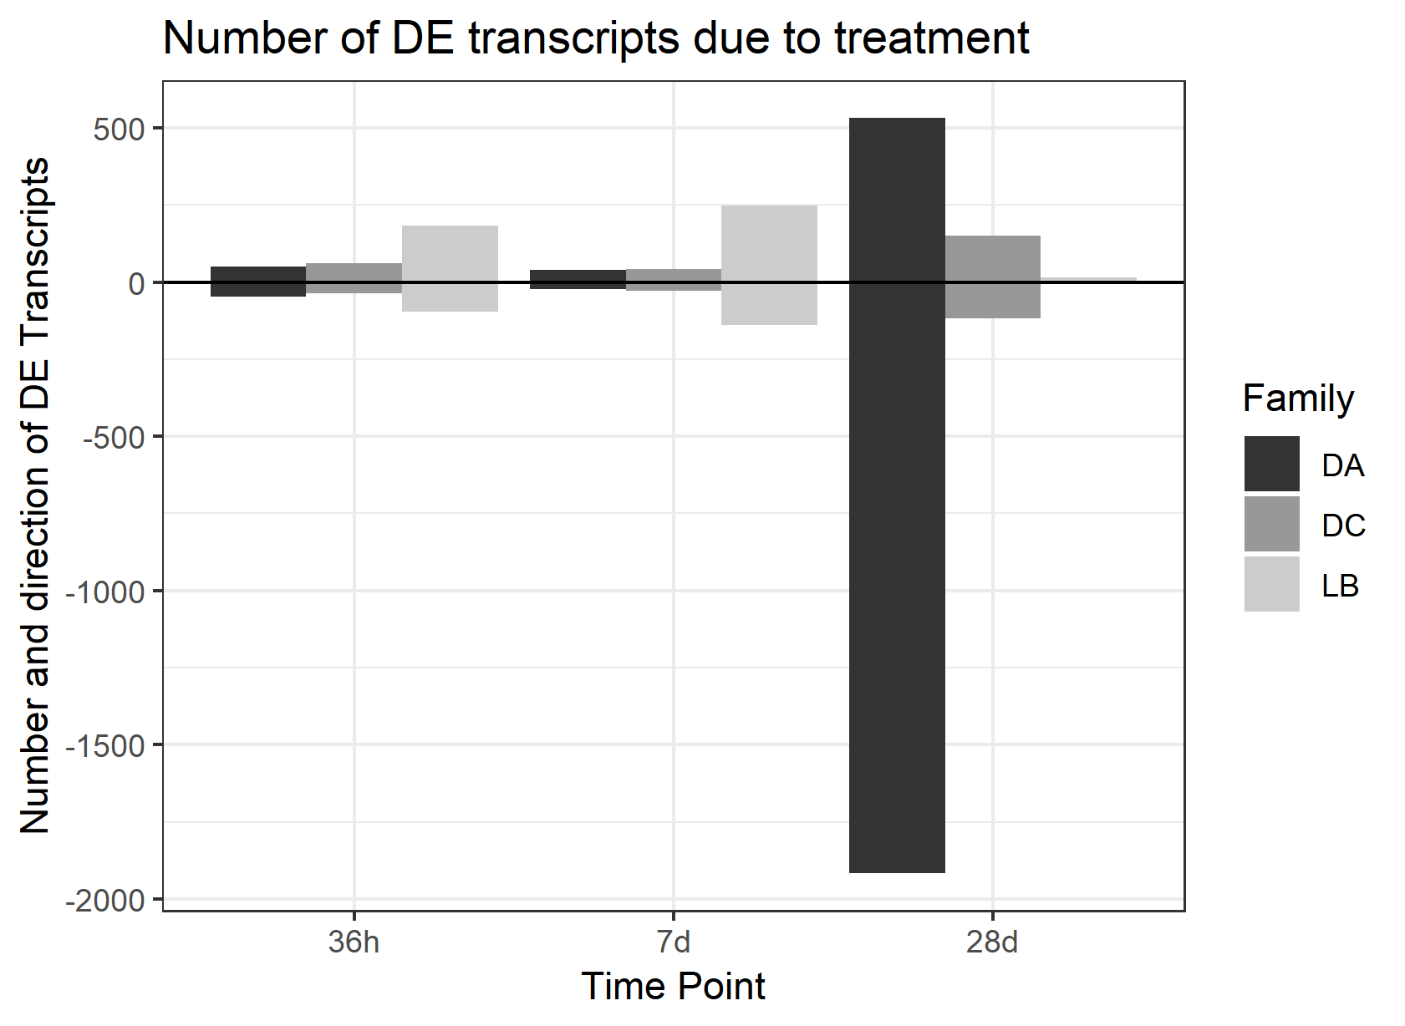

From the figure you can see differential expression within the first 7 days post-exposure is greatest in the tolerant family. The majority of DEGs are upregulated and functional annotations include oxidation-reduction processes and protease regulation. In the susceptible family, an expression response is not apparent until 28 days post-exposure. At this point the majority of the DEGs are down-regulated and associated with metabolic failure. There is some overlap between DEGs in the resistant and susceptible families at 28d post-exposure

Based on this analysis. We suggest focusing on DEGs detected at the two early timepoints for the plastic response to Dermo exposure.